Advanced SQL Server
Exercise-1:
Ranking and window functions
QUERY-
CREATE DATABASE OnlineRetailStore;
GO
USE OnlineRetailStore;
GO

CREATE TABLE Products (
ProductID INT PRIMARY KEY,
ProductName VARCHAR(100),
Category VARCHAR(50),
Price DECIMAL(10,2)
);
INSERT INTO Products (ProductID, ProductName, Category, Price) VALUES
(1, 'Laptop Pro', 'Electronics', 85000),
(2, 'Gaming Laptop', 'Electronics', 95000),
(3, 'Wireless Mouse', 'Electronics', 1500),
(4, 'Smartphone', 'Electronics', 45000),
(5, 'Office Chair', 'Furniture', 12000),
(6, 'Dining Table', 'Furniture', 30000),
(7, 'Sofa Set', 'Furniture', 55000),
(8, 'Bookshelf', 'Furniture', 18000),
(9, 'T-Shirt', 'Clothing', 1200),
(10, 'Jeans', 'Clothing', 2500),
(11, 'Jacket', 'Clothing', 4500),
(12, 'Sneakers', 'Clothing', 4500);
SELECT * FROM Products;
ROW_NUMBER()
SELECT *
FROM (
SELECT
ProductID,
ProductName,
Category,
Price,
ROW_NUMBER() OVER (
PARTITION BY Category
ORDER BY Price DESC
) AS RowNum
FROM Products
) AS RankedProducts
WHERE RowNum <= 3;
OUTPUT-
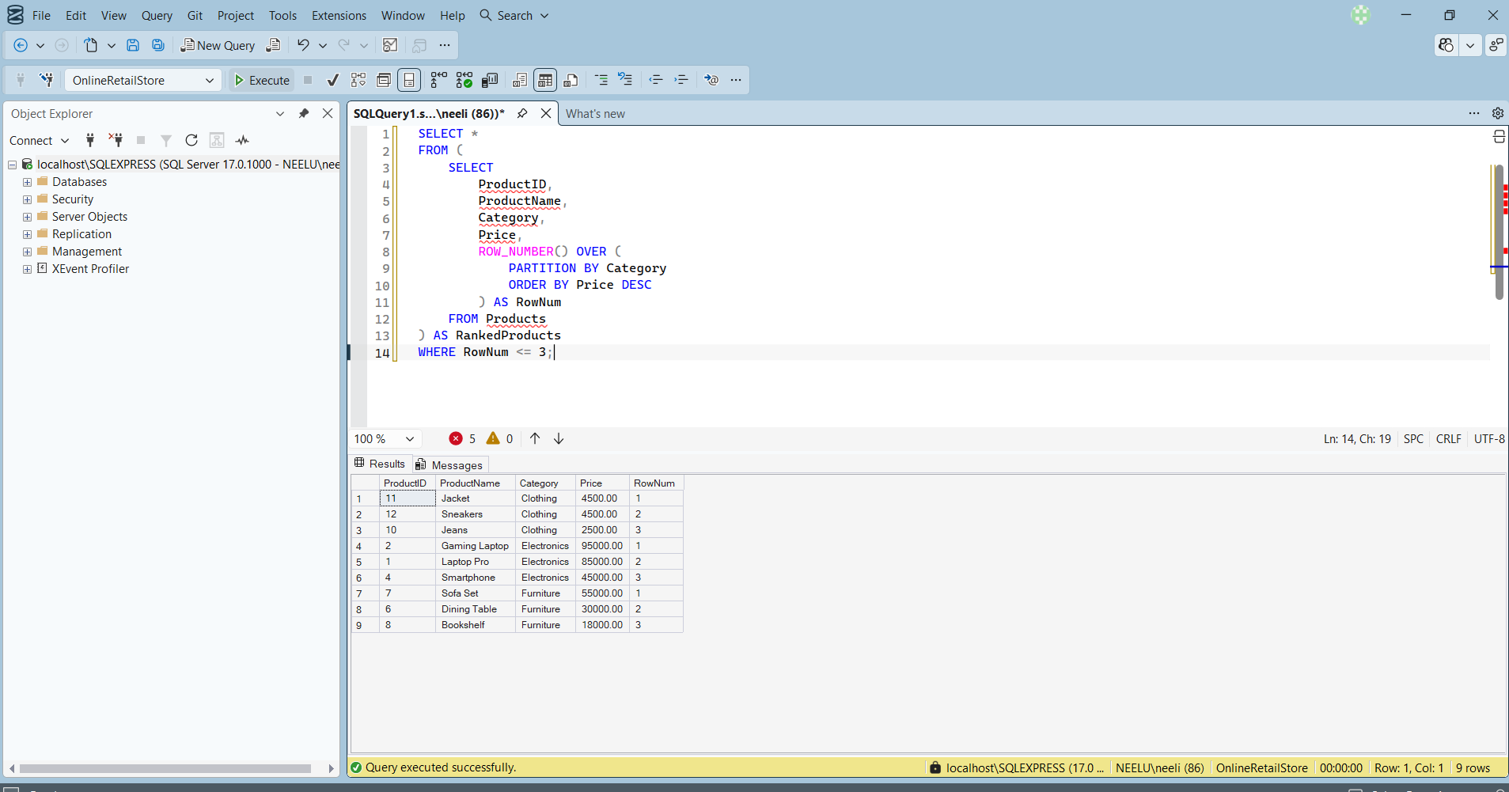
RANK()-
SELECT *
FROM (
SELECT
ProductID,
ProductName,
Category,
Price,
RANK() OVER (
PARTITION BY Category
ORDER BY Price DESC
) AS RankNo
FROM Products
) AS RankedProducts
WHERE RankNo <= 3;
OUTPUT-
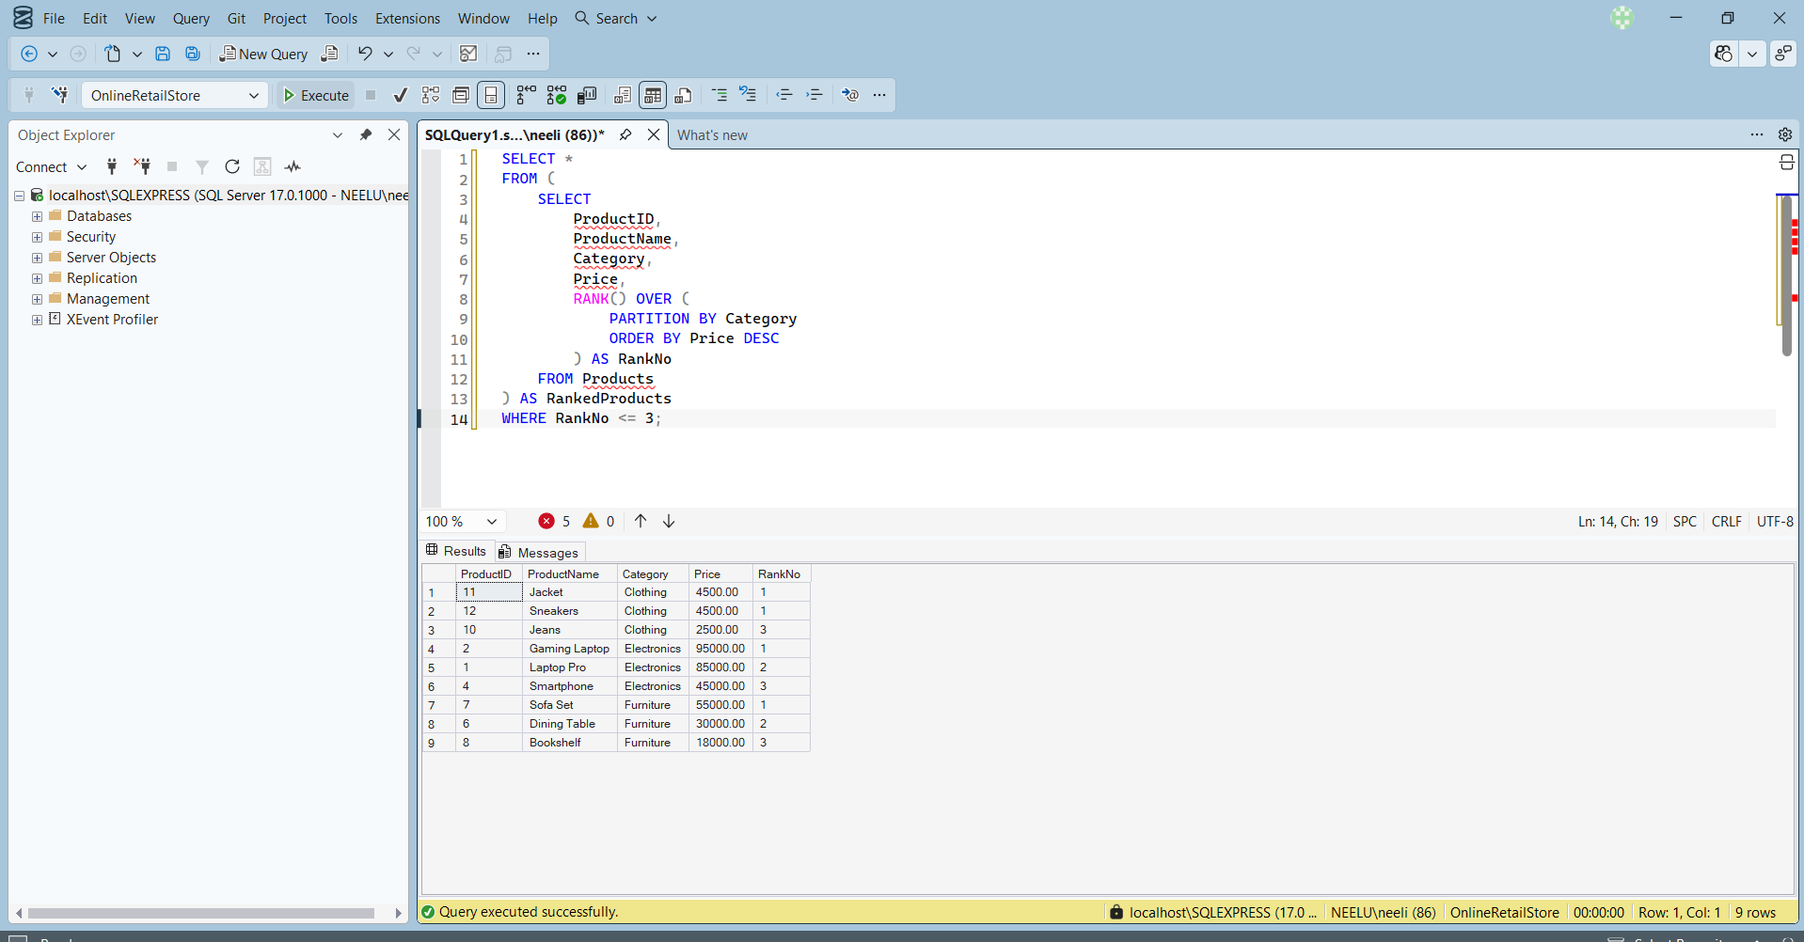
DENSE_RANK()-
SELECT *
FROM (
SELECT
ProductID,
ProductName,
Category,
Price,
DENSE_RANK() OVER (
PARTITION BY Category
ORDER BY Price DESC
) AS DenseRank
FROM Products
) AS RankedProducts
WHERE DenseRank <= 3;
OUTPUT-
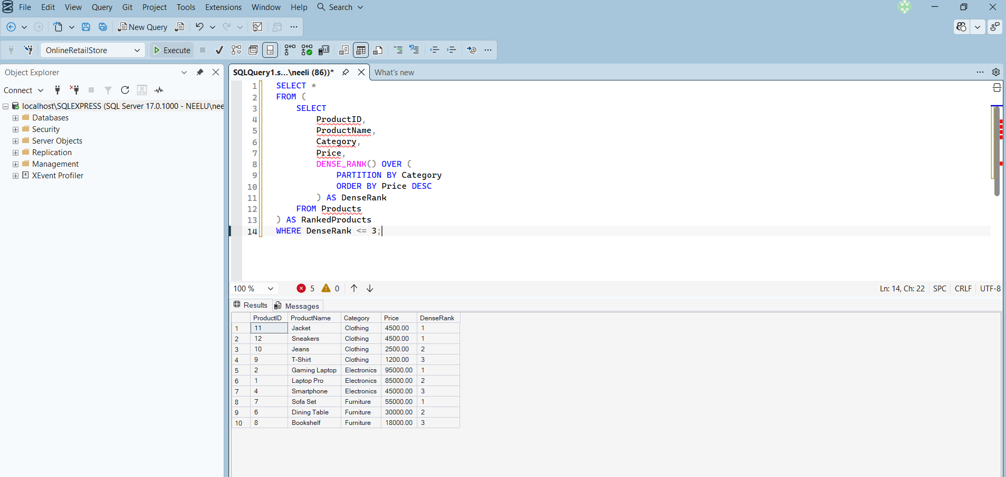
PARTITION BY-
SELECT ProductName,
Category,
Price,
ROW_NUMBER() OVER (
PARTITION BY Category
ORDER BY Price DESC
) AS RowNum
FROM Products;
ORDER BY-
ROW_NUMBER() OVER (
PARTITION BY Category
ORDER BY Price DESC
)
OUTPUT-
